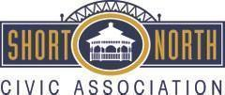

Short North Civic Association Minutes
February 1, 2024
6:30 p.m. Columbus Metropolitan Library

There was not a quorum at the meeting and no business conducted. The SNCA President provided updates about the Board’s vision for the next year, new committees, appointments, and a retrospective on the annual meeting.

