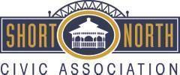

Short North Civic Association Minutes
January 18, 2024
6:00 p.m. Budd Dairy Food Hall

At the annual meeting, by secret ballot, there was a unanimous vote to accept the nomination committee’s slate of officers and board members as follows:
- President - Jack Decker
- Vice President - Chuck Fairbanks
- Secretary - Jared Cape
- Treasurer - Jim Farmer
- Board - Caroline Stinziano
- Board - Marc Conte
- Board - Bob Stern

